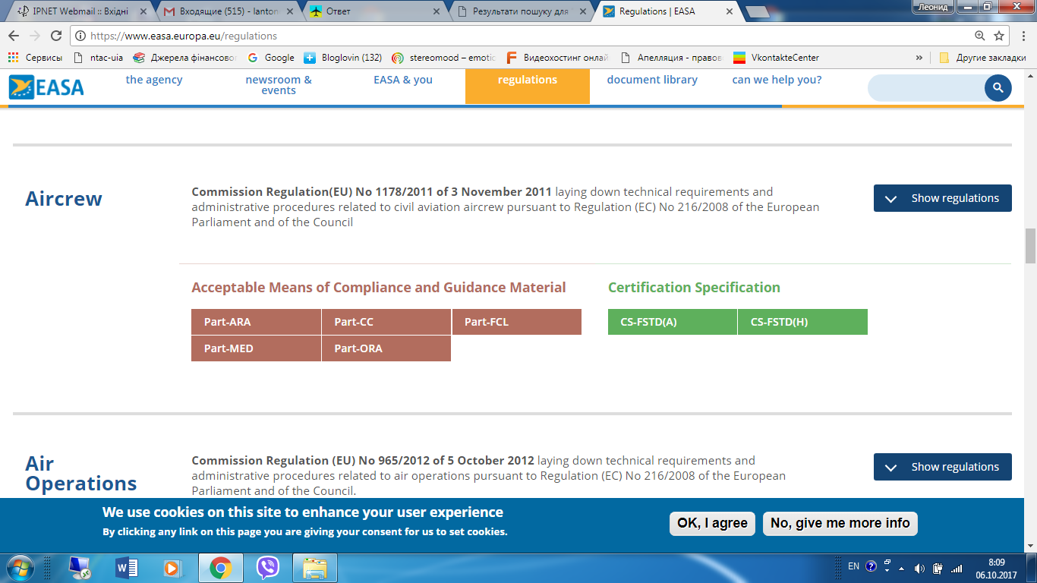

https://www.easa.europa.eu/regulations

