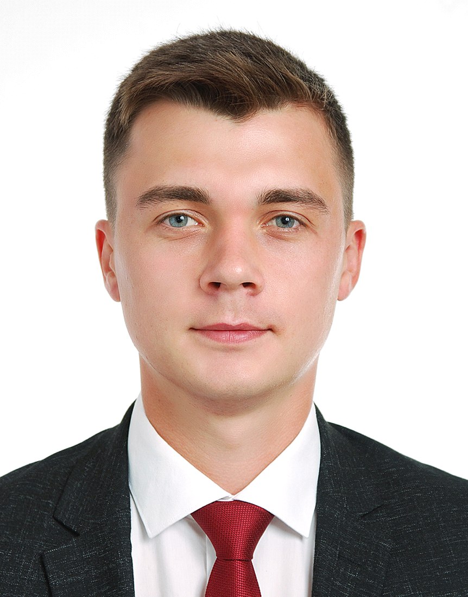

Oleksandr
Tkachuk
(24years old)
Operations Manager position
Zhashkiv, Ukraine
38(099)-417-6805
Alex21Tkachuk@gmail.com

FLIGHT TIME
- Total Time 158
- SEP 134
- MEP 24
- FNTPII 40
CERTIFICATES & RATINGS
- Commercial Pilot License (ME/IR): UA.FCL.020151
- ICAO English: Level 5
SKILLS
- Composure under high pressure
- Planning and time management
- Interpersonal communication
- Cultural awareness
- Ability of self-education

EXPERIENCE
Flight planning Dispatcher, SkyUp Airlines Kyiv, UA Jun 2018 - Sep2019
- Airport slots obtaining.
- Responsible for domestic and international CAA permits.
(including first flights to China and Europe).
- Flight/ route planning.
- Critical situation solving.
(delays caused by weather or technical reasons)

Cadet Pilot, FTO Condor Poltava, UA Feb 2020 – Dec2020
- Performing pre and post-flight inspections.
- Monitoring weather conditions.
- Communication with ATC during flight.
- Routes and flight plans analyze.

Front Desk/ Host, Bubba Gump Shrimp CO. FL, USA May2017 – Sep2017
- Greeting and consulting guests.
- Answering calls to the restaurant.

Lifeguard, Sunset Pools VA, USA May2016 – Sep2016
- Supervising swimming activities.

EDUCATION
Master's degree, Aeronavigation /Aircraft Flight Operations
Flight Academy of Ukraine
Sep2014 - Feb2020
SUMMARY
Highly motivated young specialist, with attention to details and excellent organization skills. Motivated to work, learn and grow in aviation industry.

